Data Report for Well-Life Hospital

Data Analysis
1. What is the total number of patients admitted during the four-year period?
- Fact: A total of 10,000 patients were admitted between 2021 and 2024.
- Insight: The hospital handled a substantial volume of patients over the four-year period, with admissions increasing from 1,409 in 2021 to 3,266 in 2024.
- Recommendation: Use the four-year admission volume as a baseline for planning staffing, medications, beds, medical supplies, and other hospital resources.
- Expected Outcome: Better resource allocation and improved preparedness for future increases in patient admissions.

2. How many patients were admitted each year?
- Fact:
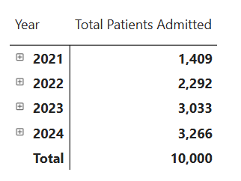
Admissions increased every year, from 1,409 in 2021 to 3,266 in 2024.
- Insight: Patient admissions more than doubled between 2021 and 2024. The largest increase occurred between 2021 and 2022, while growth slowed in 2024.
- Recommendation: Plan for continued growth while monitoring whether the slower growth in 2024 continues. Staffing and supplies should be adjusted based on recent admission patterns rather than relying only on historical averages.
- Expected Outcome: Accommodate increasing patient demand without significant pressure on staff, beds, or medical supplies.

3. What is the overall average age of admitted patients?
- Fact: The average age of admitted patient was 44 years.
- Insight: The patient population is centered on middle middle-aged adults
- Recommendation: Maintain strong adult-care services while ensuring adequate resources and capacity for younger and older patients.
- Expected Outcome: More balanced healthcare resource allocation and improved access to care across all major patient age groups.

4. What is the distribution of patient admissions across different age groups
- Fact:
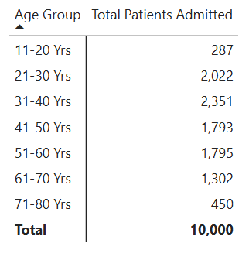

The 31–40 years age group recorded the highest admissions at 2,351 (23.51%), followed by 21–30 years at 2,022 (20.22%).

- Insight: Patients aged 21–60 years account for about 79.6% of all admissions, making working-age adults the hospital’s largest patient population

- Recommendation: Prioritize resources for adult healthcare services while maintaining adequate services for younger and elderly patients, particularly those aged 61 years and above.

- Expected Outcome: Improved healthcare delivery for the hospital’s largest patient group, while maintaining adequate care across other age groups.
5. What is the gender distribution of admitted patients?
- Fact:
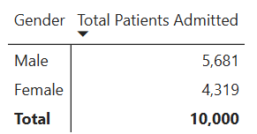
Male patients accounted for 5,681 admissions (56.81%), while female patients accounted for 4,319 (43.19%).
- Insight: Male admissions were approximately 13.62 percentage points higher than female admissions.
- Recommendation: Maintain quality healthcare services for both genders while identifying and addressing factors that may contribute to lower female admissions.
- Expected Outcome: Improved healthcare access and better understanding of gender-based admission patterns.
6. How many unique diagnosis were recorded during the four-year period?
- Fact: The hospital recorded 7 unique diagnoses.
- Insight: The diagnosis group contains both infectious diseases and chronic diseases.
- Recommendation: Maintain adequate resources for both infectious disease treatment and long-term management of chronic conditions.
- Expected Outcome: Improved capacity to manage both infectious diseases and chronic conditions, leading to better continuity and quality of patient care.

7. What is the distribution of patient admissions by diagnosis?
- Fact:
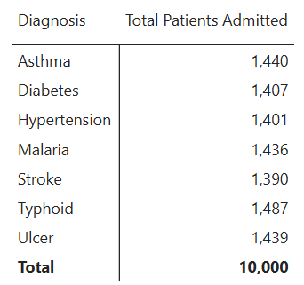
Typhoid recorded the highest number of admissions at 1,487, while Stroke recorded the lowest at 1,390.

- Insight: Admissions are evenly distributed across the seven diagnoses, with only 97 patients separating the highest and lowest diagnoses.
- Recommendation: Maintain adequate medication, equipment, and trained staff across all seven conditions.
- Expected Outcome: Improved ability to respond effectively to demand across major diagnosis group.

8. What is the distribution of patient admissions by diagnosis group using the following classifications?
- Chronic Diseases
  - Diabetes – 1,407
  - Hypertension – 1,401
  - Stroke – 1,390
  - Asthma -1,440
  - Ulcer – 1439

- Infectious Diseases
  - Malaria – 1,436
  - Typhoid – 1,487
- Fact: Chronic diseases accounted for 7,077 admissions (70.77%), while infectious diseases accounted for 2,923 (29.23%).

- Insight: Chronic conditions generated more than twice the admissions of infectious diseases, making them the dominant diagnosis group.

- Recommendation: Allocate adequate healthcare resources to both chronic and infectious disease management, with more resources directed toward chronic disease care due to its higher admission volume.

- Expected Outcome: Improved management of both chronic and infectious diseases.
9. How many patients are we expecting in the first quarter of 2025?
- Fact: The forecast estimates 752 patient admissions for Q1 2025, with a 95% confidence interval ranging from 567 to 937 patients.

- Insight: This indicates that Q1 2025 admissions are expected to be around 752 patients, but actual demand could reasonably range between 567 and 937 patients.

- Recommendation: Use the forecast of 752 patients to prepare staffing, medications, beds, and other healthcare resources ahead of Q1 2025, while maintaining additional capacity to accommodate a possible increase toward the upper estimate of 937 patient and more.

- Expected Outcome: Better preparedness for patient demand, reduced pressure on hospital resources, and more efficient allocation of healthcare resources in Q1 2025.

10. What specific recommendations can be implemented to improve resource planning in 2025?
Recommendations:
- Hospital management should prepare for increasing patient volume by planning staffing and bed capacity for approximately 3,300–3,500 admissions in 2025, or about 800–900 admissions per quarter, while maintaining a 10–15% capacity buffer for unexpected increases in demand.

- Increase capacity for chronic disease management by allocating more staff, medications, equipment, and follow-up services to conditions such as diabetes, hypertension, and asthma.

- Maintain adequate resources for infectious diseases by stocking sufficient medications, test kits, and other supplies for malaria and typhoid.

- Prioritize services for the largest patient groups by strengthening staffing, screening, consultation, diagnostic, and treatment capacity for adults aged 21–60.

- Balance resources across major diagnosis categories by maintaining adequate supplies, equipment, and clinical capacity for all seven major diagnoses.

